Webots simulator documentation

How to create a robot from scratch and control it

Content
1. World creation
2. Object concept
3. Robot creation
4. Integrating sensors
5. Robot controller

1. World creation
A World is a file containing information like where the objects are, what they look like, how they interact with each other, what is the color of the sky, how is defined the gravity, friction, masses of the objects, etc. It defines the initial state of a simulation.
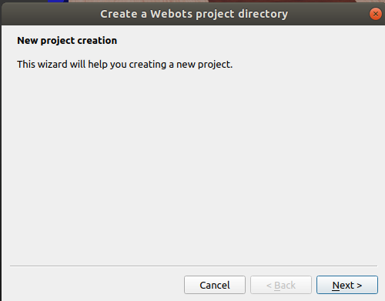
Use “wizards” tool on the top of the screen. Choose “New Project Directory” there.

Then choose name and directory for your project. You may add a rectangular area in your world or create it later yourself.
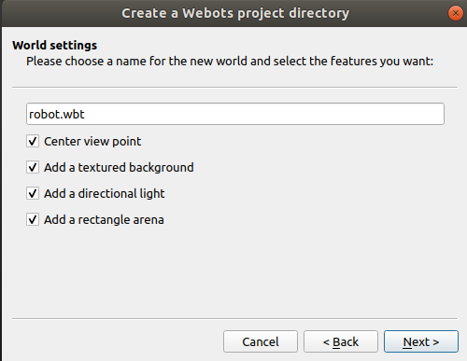

Then click Next and Finish. The world has been created.
Remember! When loading the world the simulation can get started. In order to save your changes, first, stop simulation, then reset it, and after that you can press save button. Otherwise your changes will not be saved.

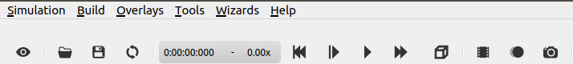
1
2
3

2. Object concept
In Webots objects are called Nodes. They are organized hierarchically in a Scene Tree on the left side. Nodes can be added using Add button (+) on the left top.
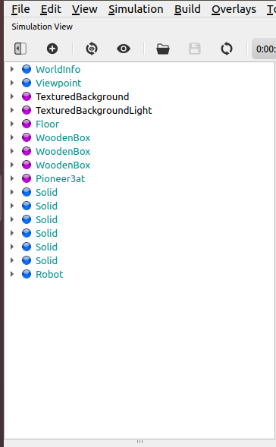
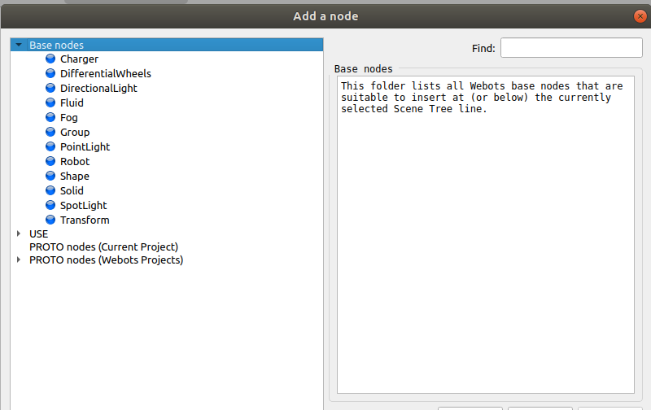

All objects can be made made using Solid nodes because the physics engine of Webots is designed for simulating rigid bodies only.
The following figure depicts a rigid body and its sub-nodes. The graphical representation of the Solid node is defined by the Shape nodes populating its children list. The collision bounds are defined in its boundingObject field. The graphical representation and the collision shape should be identical. Finally, the Physics field defines if the object belongs to the dynamical or to the static environment. Physics field needs the boundingObject to be defined.
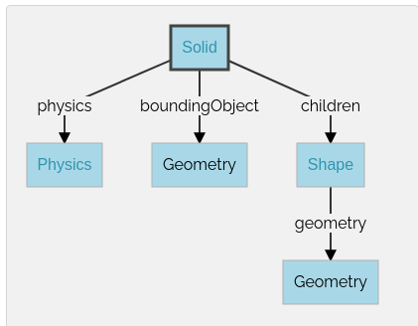

3. Robot creation
Let us make a simple 4-wheel robot.
1) To create a custom robot from scratch we need to add an object called “Robot” into the Scene Tree. The Robot node is a generic type of robot.
2) As we have a Robot node, we need to add it’s “children” (using add button on the top or right mouse click on Robot node→add new). Robot’s children are it’s body and wheels.
First, we are going to make a body. Let’s add a child from Base nodes, called Shape. This will be the robot’s body. (A Shape node is a visual object that includes both an “appearance” and a “geometry”. A Shape can also be used in a “boundingObject”).
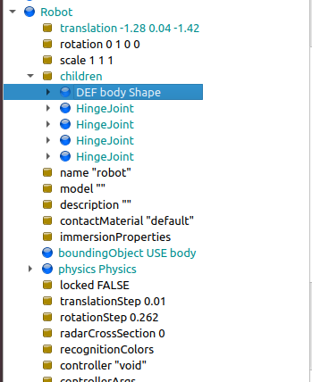

Let’s define Shape sub-node as “body” because we will use it further in “boundingObject”, which, as was said before, should be identical to the shape of an object.
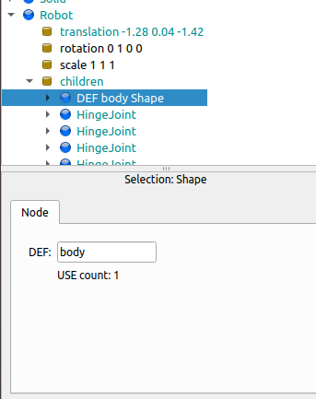

Now “body” has appeared in nodes in USE section.
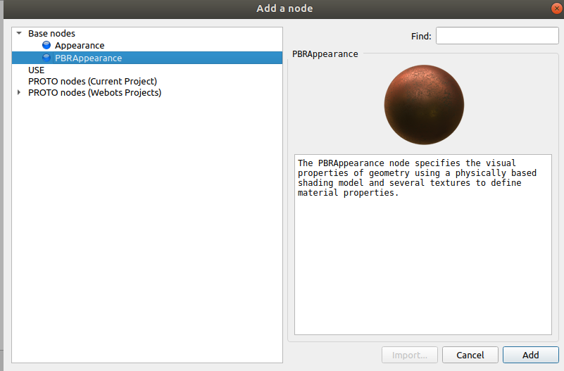
3) As we defined Shape, next step is to define “appearance” as sub-node of Shape. Click on “appearance NULL” → “Add” → ”Base nodes” → “BPRAppearance”.

BPRAppearance node specifies the visual properties of geometry.
4) Next step is to add “geometry”. “geometry NULL”→ “add new”→ “Base nodes”→ “Box”. Box is the shape of robot’s body. You can do it any shape and size using “translation” unit.
Color, roughness, metalness and other features can be changed in “appearance PBRAppearance”.
To move objects use Shift+left-click+drag. Or left-click and drag/rotate appeared arrows to move/rotate object in 3 dimentions.
5) As we are done with rectangular body of the robot
Let’s add a boundary to the robot. Find “boundingObject NULL”→ “USE”→ “body (Shape)”.
Add physics “physics NULL”→ “add new”→ “Base nodes”→ “Physics”.
A Physics node allows to specify the physical properties (density, mass, friction coefficient, etc.) of the solid object that contains it. When a Physics node is added to a solid object, this indicates that the dynamics (forces, gravity, friction, inertia, etc.) of the object must be simulated, otherwise only the kinematics is simulated.
6) Next we are going to create 4 wheels. Go no node “Robot”→ “children”→ “add”→ “Base nodes”→ “HingeJoint”.

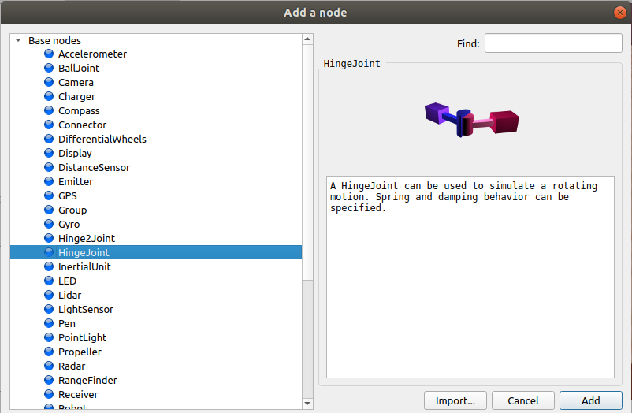

A HingeJoint can be used to simulate a rotating motion.
Go inside “HingeJoint” node. Define “jointParameters” as “HingeJointParameters” using “add” command.
To “device” add “RotationalMotor”. The RotationalMotor node can be used by a robot controller program to generate a rotational motion around its hinge axis.
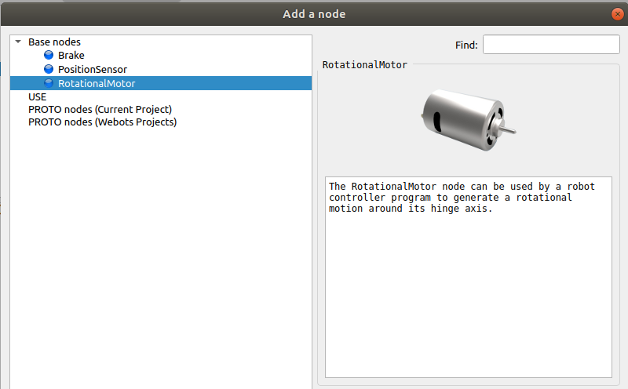

Next go to “endPoint solid”. And as shown on the picture below go to “children” and define name to the Shape “wheel” as we did it in 2nd step with robots body.

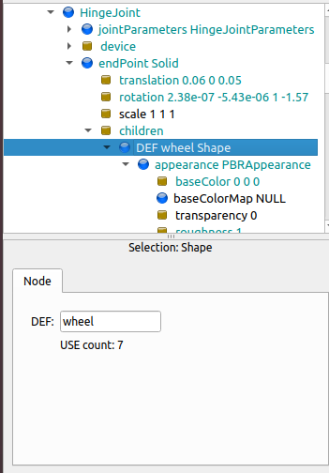

Here on the picture is also shown that we need to add appearance “PBRAppearance”. Under the “appearance” you see “geometry”. Add a “cyllinder” to geometry.
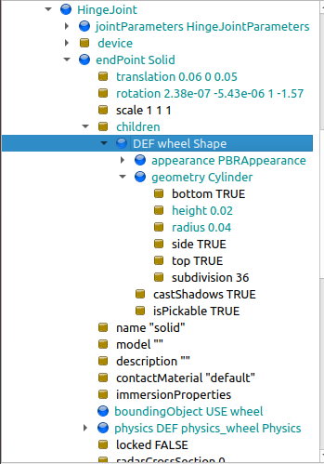

Next specify “height” and “radius” of the wheel as you want.
Choose “wheel” as “boundingObject” (in USE section). Define “Physics” as “physics_wheel” in DEF section as we did it 2 times before with “body” and “wheel”.
As we defined “Physics” as “physics_wheel” in one wheel, we are going to use it in the rest 3 wheels.
7) Create the rest of the wheels.
Go “Robot”→ “children”→ “add”→ “HingeJoint”
“ jointParameters”→ “HingeJointParameters”
“device”→ “ RotationalMotor”
“endPoint”→ “Solid”
“children”(of endPoint)→ “add”→ “USE”→ “wheel”
“boundingObject”(in children)→ “add”→ “USE”→ “wheel”
“Physics”(in children)→ “add”→ “USE”→ “physics_wheel”
Don’t forget to change translation of wheels and their angle so that they fit exactly to the robot's body:
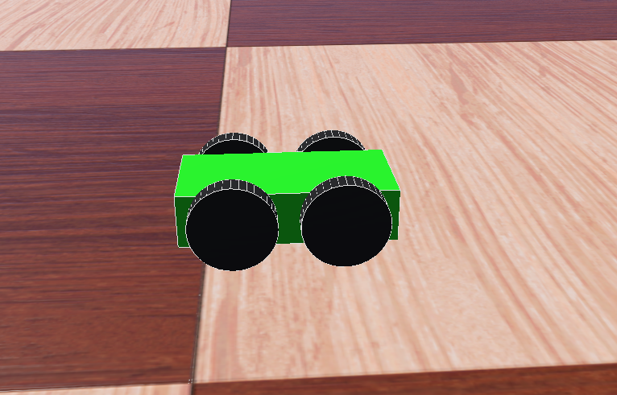
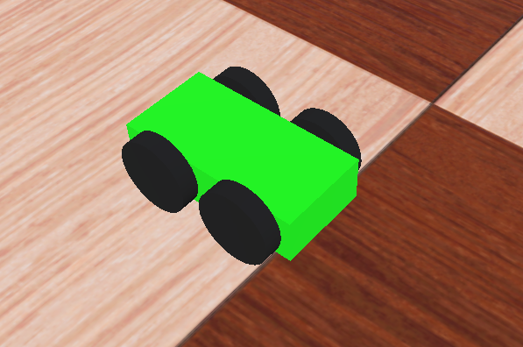

Create the rest 2 wheels the same way as the 2nd wheel was created.

4. Integrating sensors
To make robot recognize obstacles we are going to create 2 distance sensors.
1) Go to “children” of “Robot” node and add a child called “DistanceSensor”.
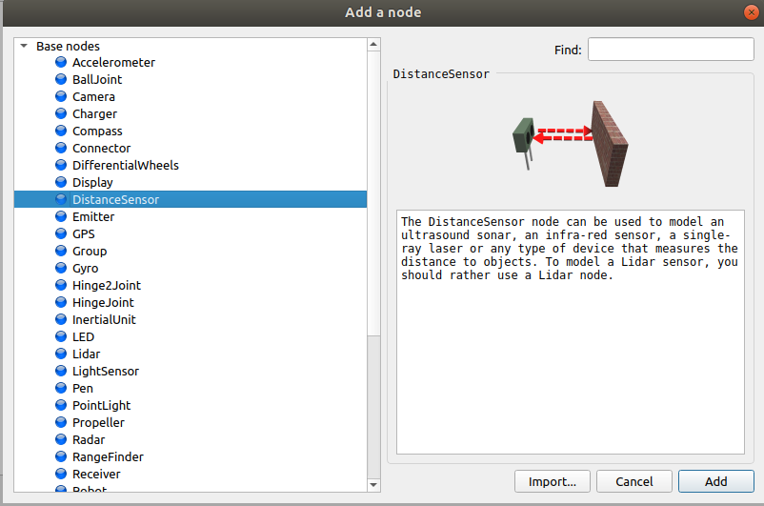

Go to sensor’s children and add a Shape. In Shape add “geometry” as Box and “appearance” as PBRAppearance. In “appearance” you can change color, shape and size of sensor as you want.
Remember! Distance sensor gives a beam along it’s X-axes (red in color), so rotate the sensor until X-axes is in the front:
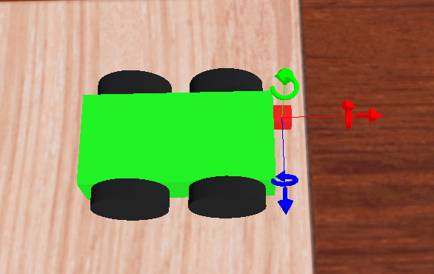

In children we have a Shape, define it as “sensor”. In boundingBox in USE choose “sensor”. In Physics choose “Physics”.
Rename sensor as “ds_left”:

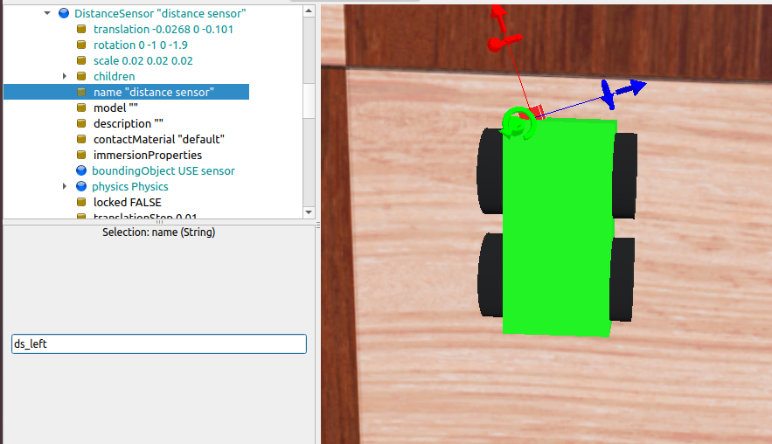
2) To make a 2nd sensor copy the first one directly in the Scene Tree and paste it there.
Rename 2nd sensor as “ds_right”. Change it’s translation and rotation.
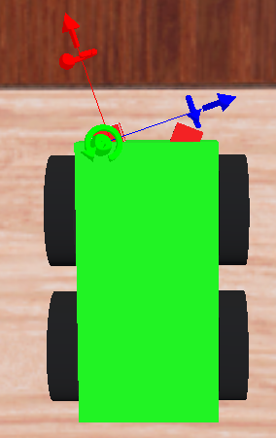
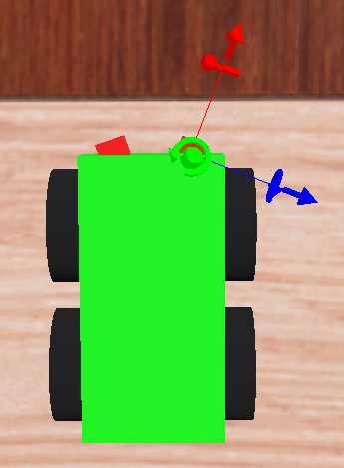

To see sensors’ beams go to “View” on the top of the screen, choose “Optional rendering”→ “Show DistanceSensor Rays”.

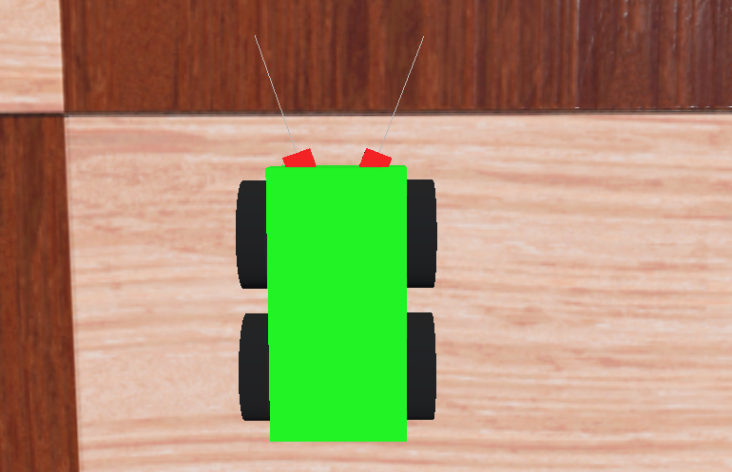

Length of rays (min and max) can be changed in “lookupTable”:

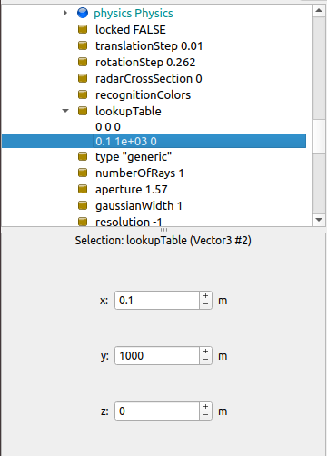

5. Robot controller
1) Change names of wheels (as they will be used in the controller and have to be different).
Go to “HingeJoint”→ “device”→ “RotationalMotor”→ “name”. Change name of each wheel from “rotational motor” to “wheel_1”, “wheel_2” ect.
2) Append rotation axes.
Rotation axes of wheels can be appended using “anchor” option in “HingeJoint”→ “jointParameters”. Rotation axes must be equal to position (i.e. translation) of the wheel.
3) Make robot controller.
Go to “Wizards”→ “New Robot Controller”. Choose an appropriate language, then choose a name, allow Webots to show your controller file in Text Editor and click “Finish”.
Now the controller file can be seen on the right side.
Go to “Robot”→ “controller” (it is void by default) and change “void” to your controller’s name.
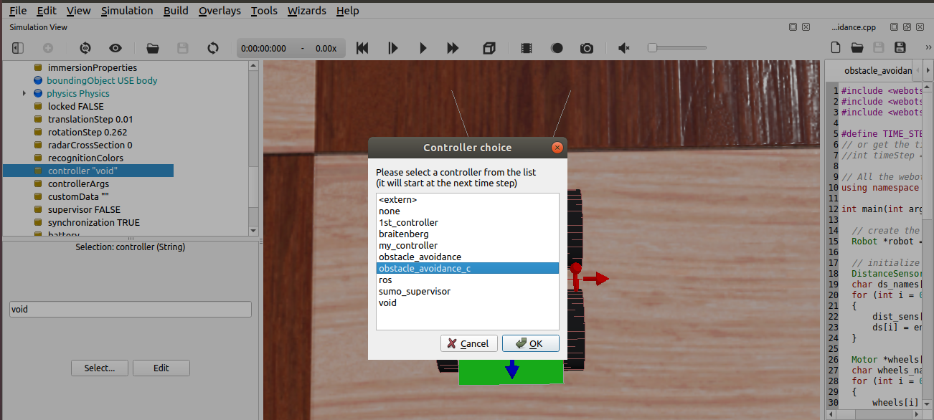
Obstacle avoidance code (C, C++, Python):
C | #include <webots/distance_sensor.h>  #include <webots/motor.h>  #include <webots/robot.h>  #define TIME_STEP 64  int main(int argc, char **argv) {  wb_robot_init();  int i;  bool avoid_obstacle_counter = 0;  WbDeviceTag ds[2];  char ds_names[2][10] = {"ds_left", "ds_right"};  for (i = 0; i < 2; i++) {  ds[i] = wb_robot_get_device(ds_names[i]);  wb_distance_sensor_enable(ds[i], TIME_STEP);  }  WbDeviceTag wheels[4];  char wheels_names[4][8] = {"wheel1", "wheel2", "wheel3", "wheel4"};  for (i = 0; i < 4; i++) {  wheels[i] = wb_robot_get_device(wheels_names[i]);  wb_motor_set_position(wheels[i], INFINITY);  }  double ds_values[2];  for (i = 0; i < 2; i++)  ds_values[i] = wb_distance_sensor_get_value(ds[i]);  if (ds_values[0] < 950.0 || ds_values[1] < 950.0)  {  left_speed = 2.0;  right_speed = -2.0;  }  else  {  left_speed = 2.0;  right_speed = 2.0;  }  wb_motor_set_velocity(wheels[0], left_speed);  wb_motor_set_velocity(wheels[1], right_speed);  wb_motor_set_velocity(wheels[2], left_speed);  wb_motor_set_velocity(wheels[3], right_speed);  }  wb_robot_cleanup();  return 0; // EXIT_SUCCESS  }
C++ | // add the include directives corresponding to the Robot,  // the DistanceSensor and the Motor nodes in order to be  // able to use the corresponding API  #include <webots/DistanceSensor.hpp>  #include <webots/Motor.hpp>  #include <webots/Robot.hpp>  // duration of each physics step  #define TIME_STEP 64  // use the Webots namespace which is required to use the Webots classes  using namespace webots;  int main(int argc, char **argv) {  // create the Robot instance (allocate dynamic memory)  Robot *robot = new Robot();  // initialize devices  DistanceSensor *ds[2];  char dsNames[2][10] = {"ds_right", "ds_left"};  for (int i = 0; i < 2; i++) {  ds[i] = robot->getDistanceSensor(dsNames[i]);  ds[i]->enable(TIME_STEP); // every 64 ms we get data  // from sensors  }  // initialize motors  Motor *wheels[4];  char wheels_names[4][8] = {"wheel_1", "wheel_2", "wheel_3", "wheel_4"};  for (int i = 0; i < 4; i++) {  wheels[i] = robot->getMotor(wheels_names[i]);  wheels[i]->setPosition(INFINITY);  wheels[i]->setVelocity(0.0);  }  // feedback loop: step simulation until receiving an exit event  while (robot->step(TIME_STEP) != -1) {  double leftSpeed;  double rightSpeed;  std::cout<<ds[0]->getValue()<<"=Right Sensor"<<std::endl;  std::cout<<ds[1]->getValue()<<"=Left Sensor"<<std::endl;  for (int i = 0; i < 2; i++) {  if (ds[i]->getValue() < 950.0)  {  leftSpeed = 2.0; // turn right  rightSpeed = -2.0;  }  else  {  leftSpeed = 2.0; // go forward  rightSpeed = 2.0;  }  }  wheels[0]->setVelocity(leftSpeed);  wheels[1]->setVelocity(rightSpeed);  wheels[2]->setVelocity(leftSpeed);  wheels[3]->setVelocity(rightSpeed);  }  // clean up memory  delete robot;  return 0; // EXIT_SUCCESS  }
Python | from controller import Robot  TIME_STEP = 64 # duration of each physics step  robot = Robot()  ds = []  dsNames = ['ds_right', 'ds_left']  # get data from sensors every 64 ms  for i in range(2):  ds.append(robot.getDevice(dsNames[i]))  ds[i].enable(TIME_STEP)  # initialize motors  wheels = []  wheelsNames = ['wheel_1', 'wheel_2', 'wheel_3', 'wheel_4']  for i in range(4):  wheels.append(robot.getDevice(wheelsNames[i]))  wheels[i].setPosition(float('inf'))  wheels[i].setVelocity(0.0)  # feedback loop: step simulation until receiving an exit event  while robot.step(TIME_STEP) != -1:  for i in range(2):  print(ds[i].getValue())  if ds[i].getValue() < 950.0:  leftSpeed = 2.0  rightSpeed = -2.0  else:  leftSpeed = 2.0  rightSpeed = 2.0  wheels[0].setVelocity(leftSpeed)  wheels[1].setVelocity(rightSpeed)  wheels[2].setVelocity(leftSpeed)  wheels[3].setVelocity(rightSpeed)

Keyboard control code (C++):
C++ | #include <webots/DistanceSensor.hpp>  #include <webots/Motor.hpp>  #include <webots/Robot.hpp>  #include <webots/Keyboard.hpp>  #define TIME_STEP 64  using namespace webots;  int main(int argc, char **argv) {  Robot *robot = new Robot(); // allocate dynamic memory  Keyboard kb;  DistanceSensor *ds[2];  char dsNames[2][10] = {"ds_right", "ds_left"};  for (int i = 0; i < 2; i++) {  ds[i] = robot->getDistanceSensor(dsNames[i]);  ds[i]->enable(TIME_STEP);  }  Motor *wheels[4];  char wheels_names[4][8] = {"wheel_1", "wheel_2", "wheel_3", "wheel_4"};  for (int i = 0; i < 4; i++) {  wheels[i] = robot->getMotor(wheels_names[i]);  wheels[i]->setPosition(INFINITY);  wheels[i]->setVelocity(0.0);  }  kb.enable(TIME_STEP);  double leftSpeed = 0.0;  double rightSpeed = 0.0;  while (robot->step(TIME_STEP) != -1) {  int key=kb.getKey();  if (key==315){ // top arrow is pressed  leftSpeed = 5.0;  rightSpeed = 5.0;  } else if (key==317){ // bottom arrow is pressed  leftSpeed = -5.0;  rightSpeed = -5.0;  }else if (key==316){ // right arrow is pressed  leftSpeed = 5.0;  rightSpeed = -5.0;  }else if (key==314){ // left arrow is pressed  leftSpeed = -5.0;  rightSpeed = 5.0;  }else {  leftSpeed = 0.0;  rightSpeed = 0.0;  }  // get values from sensors  std::cout<<ds[0]->getValue()<<"=Right Sensor"<<std::endl;  std::cout<<ds[1]->getValue()<<"=Left Sensor"<<std::endl;  wheels[0]->setVelocity(leftSpeed);  wheels[1]->setVelocity(rightSpeed);  wheels[2]->setVelocity(leftSpeed);  wheels[3]->setVelocity(rightSpeed);  }  delete robot; // clear memory (as it was dynamically allocated)  return 0; // EXIT_SUCCESS  }

